

**Ask for Easy Read information about Breast Screening**

Breast screening is for women aged 50 and older.

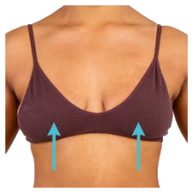

Breast screening checks are to see if your breasts (boobs) are healthy



When you are invited for a breast screening check you can ask for an **accessible or easy read letter** to explain what will happen.

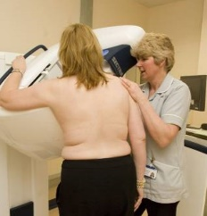

At the breast screening unit, you will have images taken of your breasts. These are called **mammograms**.

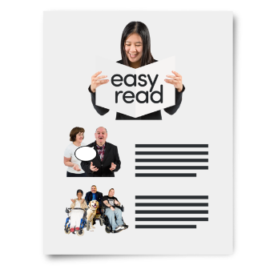

After your breast check (mammogram) you are sent your results. You can ask for your results letters to be in easy read.

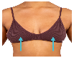



**Please tell the Breast Screening Service or your Doctor or nurse if you need easy read letters or invitations**



